- Common Logarithms.
1. The product of a and 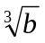is 31.59. Given that logarithm of a is 2.6182. Find using logarithm the value of b. to 4 significant figures. (4mks)
2. Evaluate without using mathematical tables or calculators,
2 log₁₀ 5 – ½ log₁₀ 64 + 2 log₁₀ 40. (3mks)
3. Use logarithm table to evaluate. (4 marks)

3 (0.0246)² x 142
0.002 x 1.14
4. Without using log tables or a calculator; solve (4mks)
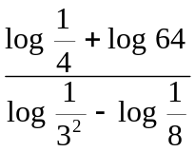

5. Solve for x given
1 ^{x} .64² = 256 (3 marks)
8

6. Use logarithms to evaluate 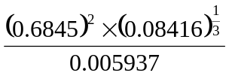 (4mks)
7. Use logarithms to evaluate (4 marks)
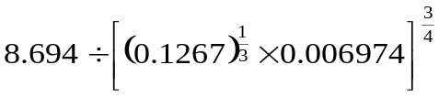

8. Use mathematical table to evaluate.
2849 x 0.00574
4
36.89 ÷ 0.023

9. Given that y = Bx^{n}. Make n the subject of the formula and simplify your answer

10. Without using mathematical tables or calculators evaluate: 6log₂ 64 + 10log₃ (243)

11. Find the value of x that satisfies the equation log (2x – 11) – log 2 =log 3 – log x

12. Use logarithms to evaluate to 3 significant figures
(0.5241)² x 83.59
³ 0.3563

13. Use logarithm tables in all your steps to evaluate:
38.32 x 12.964
86.37 x 6.285
3
leaving your answer to four decimal places

14. Make L the subject in :
3 3d (L – d)
10L
H =

15. Using logarithm tables solve.
¼
6.195 x 11.82
83.52

16. Solve the simultaneous equation:-
Log (x-1) + 2log y = 2log3
log x + log y = log 6

17. Without using logarithms tables or calculator evaluate:-
4 log₁₀32 + log₁₀50-3log₁₀ 2
5
18. Use logarithms to evaluate:-
6.598
(0.9895)² x 0.004974 ^{0.75} and express the answer in standard form

19. Solve for x given that :- log (3x + 8) – 3log2 = log (x-4)

20. In this question, show all the steps in your calculations, giving your answer at each stage.
Use logarithms correct to 4 decimal places to evaluate:
36.72 x (0.46)²
3
185.4

21. Use logarithms to evaluate correct to 4 s.f
½
sin 44.5
tan 14.90 x cos 82

22. Without using logarithm tables evaluate:

3.264 x 1.215 x 12.25
3
1.088 x 0.4725

23. Without using a calculator/mathematical tables, solve: Log₈ (x + 5) – log₈(x -3) = Log₈ 4

24. Use tables to calculate ;(6.57² + 6.57) ÷ (7.92² x 30.08)(Give your answer to 4 decimal places)
25. If log^{₂} = 0.30103, and log^{₃} = 0.47712, calculate without using tables or calculators the
value of log120

26. Solve for x in the following equation; Log₂(3x -4) = 1 log₂8x⁶ – log₂4 3
27. By showing all the steps, use logarithms to evaluate: 5.627 x (0.234)³
(8.237) ^{½}
28. Solve the logarithimic equation: log₁₀ (6x – 2) – 1 = log₁₀ (x-3)

29. In this question, show all the steps in your calculations, giving your answers at each stage.
Use logarithms, correct to 4 d.p to evaluate:-

(0.07526)²
3
1.789 + 4.863

30. Evaluate using logarithms
4.283 x (0.009478)²
Log 9.814

